DBMS Project Report

Submitted for
DATABASE MANAGEMENT SYSTEM (UCS310)

PROJECT TITLE: CampusPay – RFID-Based Unified Tap & Pay System for College Campus

Submitted by:
Ikansh Mahajan (102303754)
Prisha Aggarwal (102303758)
Parth Biyani (102303759)

Submitted to:

Dr. Swati Sharma



Computer Science and Engineering Department Thapar Institute of Engineering & Technology, Patiala Jan-June 2025

Table of Contents
Introduction 2
Problem Statement 3
ER Diagram 4
ER to Table Mapping 5
Normalized Tables 6
Sample Database 7
SQL Queries 9
Query to find the transaction between 4pm and 7pm grouped by scanner 9
Query to display the users with balance lower than ₹900: 9
PL/SQL Functions and Procedures and their executions 10
get_balance() function: 10
update_wallet_active_status procedure: 11
process_topup procedure 13
process_transaction procedure: 15
process_p2p_payment procedure 17
Conclusion 21
References 22

Introduction
The "CampusPay" system introduces a ground-breaking RFID-based unified Tap-and-Pay system tailored for Thapar Institute of Engineering and Technology (TIET), harnessing the existing RFID-enabled ID cards issued to students, faculty, and staff. This project seeks to unify the fragmented payment ecosystem across the TIET campus, replacing the myriad of apps and payment methods currently used at canteens, libraries, stationery shops, and hostels with a single, efficient RFID-based unified Tap-and-Pay system. By deploying custom RFID scanners linked to a centralized SQL database, CampusPay facilitates fast, secure, and reliable transactions, reducing reliance on internet connectivity at point-of- sale (POS) terminals. The system is supported by a robust backend featuring tables for users, wallets, scanners, transactions, and top-ups, managed through PL/SQL procedures that handle payments, top-ups, peer-to-peer transfers, and wallet status updates.
CampusPay enhances user convenience while promoting sustainability by minimizing the need for multiple digital payment platforms, thus lowering the associated digital footprint. For vendors, the RFID-based unified Tap-and-Pay system simplifies reconciliation and settlement, ensuring accurate and timely financial reporting. The system incorporates security features, such as wallet deactivation via the “is_active” flag and centralized transaction logging, to prevent fraud and maintain data integrity. Furthermore, its scalable architecture opens opportunities for future enhancements, such as advanced analytics for spending trends and integration with campus resource management tools. Through this initiative, TIET positions itself as a leader in technological innovation, fostering a cashless, efficient, and inclusive campus environment that aligns with the institute’s vision of embracing smart solutions by a payment method made by the students of the college.

Problem Statement
At Thapar Institute of Engineering and Technology, the current payment landscape suffers from a lack of uniformity, with students and staff relying on various apps and methods—such as UPI apps (Google Pay, PhonePe), vendor- specific platforms, and cash—to conduct transactions across campus facilities. This fragmentation results in an inconsistent user experience, where individuals must navigate multiple platforms, often facing delays due to internet issues or app-specific limitations. For vendors, managing diverse payment systems complicates end-of-day reconciliation, delays settlements, and increases the likelihood of errors in financial reporting. Moreover, the absence of a centralized system limits the administration’s ability to monitor transactions, analyze spending patterns, or ensure financial oversight effectively.
The lack of a unified payment solution also raises concerns about scalability and security as the campus expands. Handling multiple payment methods becomes increasingly unsustainable, and the absence of centralized control heightens the risk of fraudulent activities. The "CampusPay" RFID-based unified Tap-and-Pay system addresses these challenges by implementing a solution that leverages existing ID cards. Integrated with low-cost RFID scanners and a secure SQL backend, it ensures seamless transactions, reduces operational overhead for vendors, and provides a scalable platform for future growth. This initiative aims to create a cohesive, secure, and efficient RFID-based unified Tap-and-Pay system that enhances the campus experience for all stakeholders.

ER Diagram

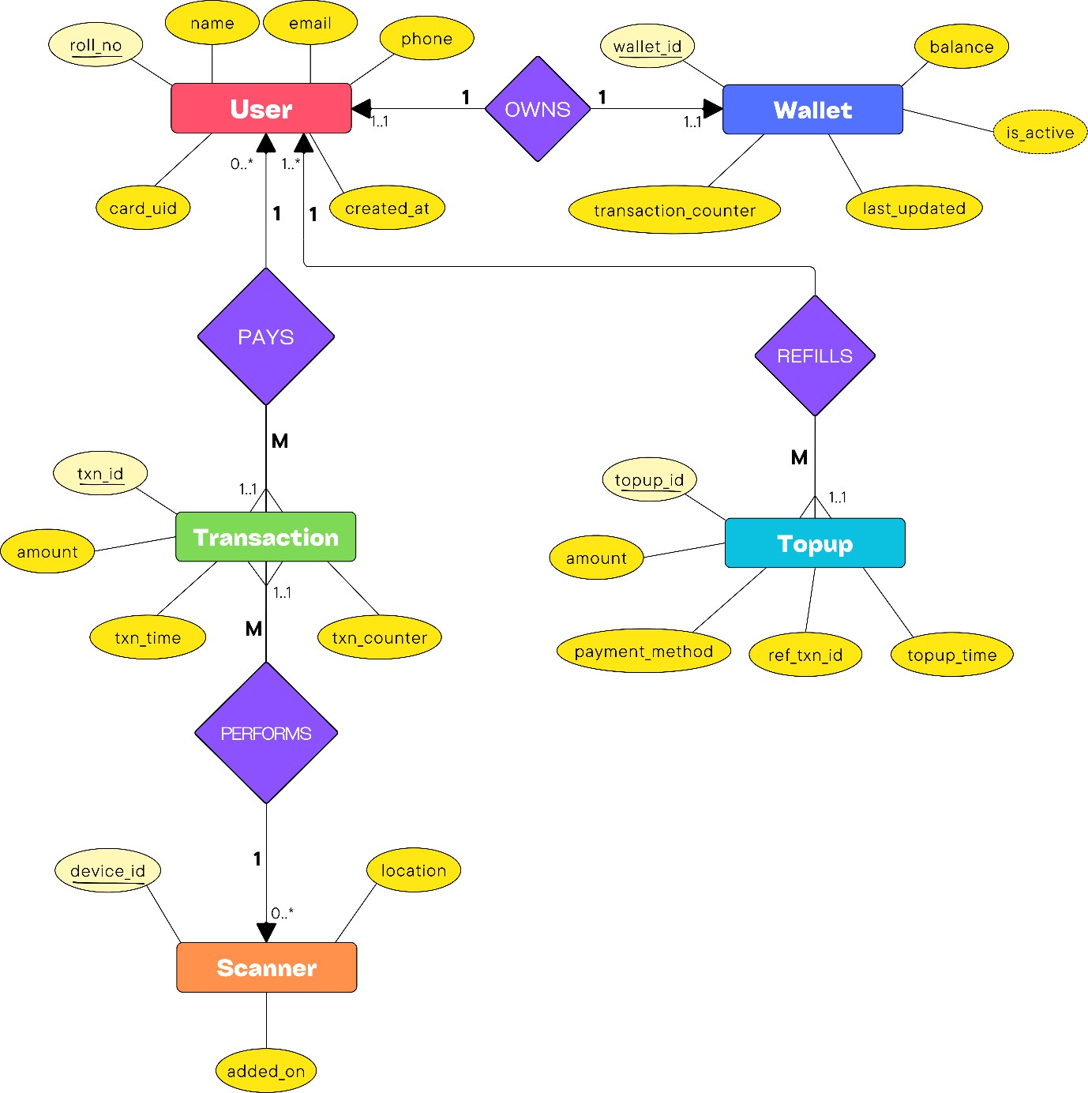

ER to Table Mapping

Entity | Table Name | Attributes
User | users | Roll_no, name, email, phone, card_uid, created_at
Wallet | wallets | wallet_id, roll_no, balance, transaction_counter, last_updated
Transaction | transactions | txn_id, roll_no, amount, location, txn_time, txn_counter, device_id
Topup | topups | topup_id, roll_no, amount, payment_method, rref_txn_id, topup_time
Scanner | scanners | device_id, location, added_on

In mapping the conceptual ER Diagram to relational tables, we define primary keys and foreign keys and impose cardinalities: the one-to-one relationship of User–Wallet is facilitated by a UNIQUE constraint on wallets.roll_no, and the one-to-many User–Transactions and User–Topups relationships are based on non-null foreign keys with ON DELETE RESTRICT for historical integrity. Check constraints on topup and transaction values ensure they are positive, and default values (wallets.transaction_counter default 0) ensure initialization. Folding relationship entities like PAYS and REFILLS into transactions and topups tables directly, we eliminate unnecessary join tables, achieving third- normal-form—eliminating multi-valued attributes and update anomalies— without sacrificing auditability through immutable timestamps.

Normalized Tables
All five tables conform to the Third Normal Form: each has a primary key, attributes are atomic, and no non-key attribute depends on another non-key attribute. Foreign keys link related tables without redundancy.

users
  - Primary Key: roll_no
  - Atomic fields: name, email, phone, card_uid, created_at
  - No repeating groups or transitive dependencies.

wallets
  - Primary Key: wallet_id
  - Foreign Key: roll_no → users
  - Attributes balance, transaction_counter, last_updated describe only the wallet.
  - One-to-one link via roll_no ensures no redundant user data.

transactions
  - Primary Key: txn_id
  - Foreign Key: roll_no → users, device_id → scanners
  - Stores only event details (amount, txn_time, location, txn_counter).
  - No duplication of user or scanner attributes.

topups
  - Primary Key: topup_id
  - Foreign Key: roll_no → users
  - Atomic attributes: amount, payment_method, ref_txn_id, topup_time.
  - Each refill is logged independently, with no redundant balance data.

scanners
  - Primary Key: device_id
  - Atomic attributes: location, added_on.
  - No multi-valued or derived fields; each scanner is uniquely identified.

Sample Database
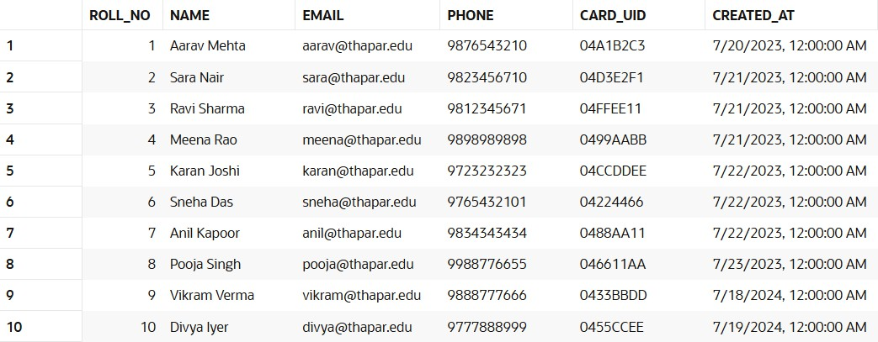
Users table:

Wallets table:
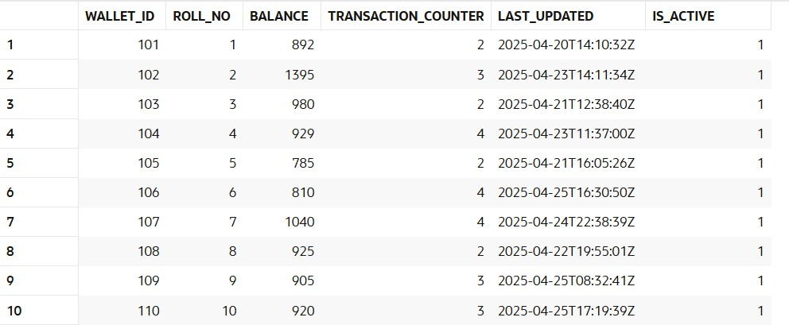

Scanners table:
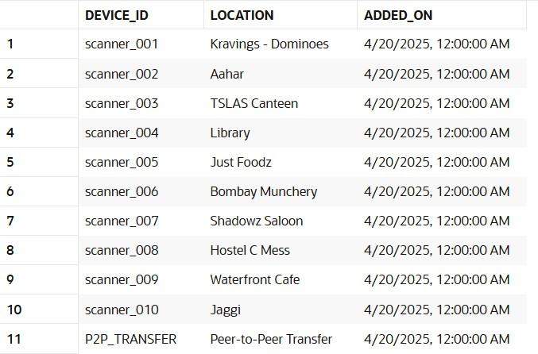

Transactions table:
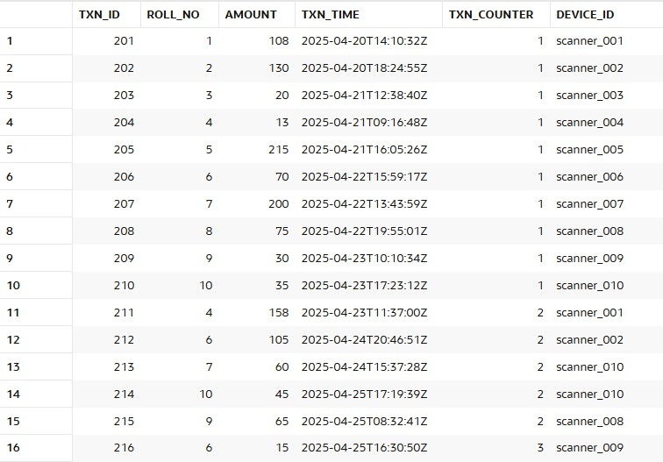

Topups table:
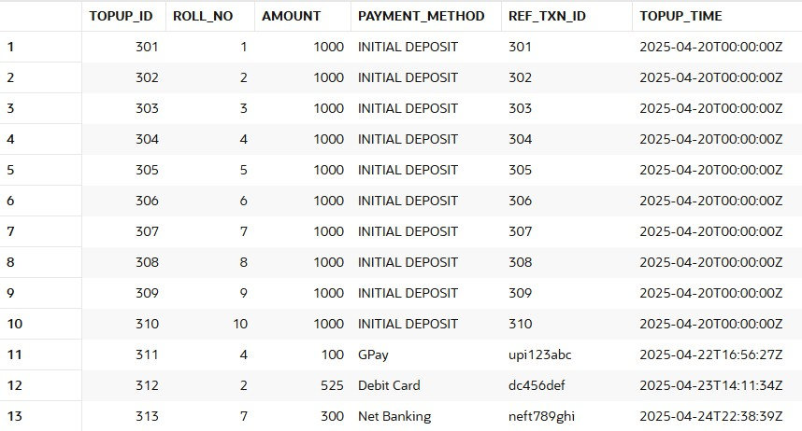

SQL Queries
Query to find the transaction between 4pm and 7pm grouped by scanner:
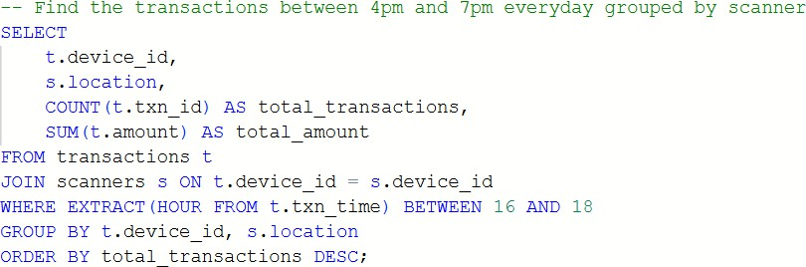

Output:
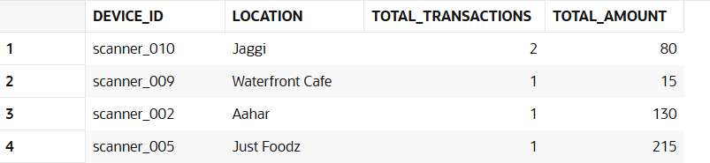

Query to display the users with balance lower than ₹900:
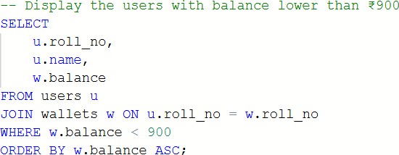

Output:
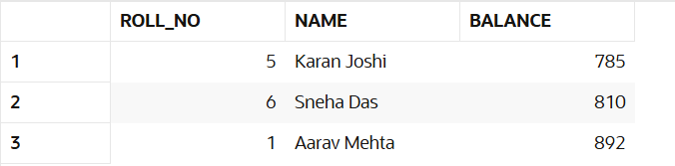

PL/SQL Functions and Procedures and their executions
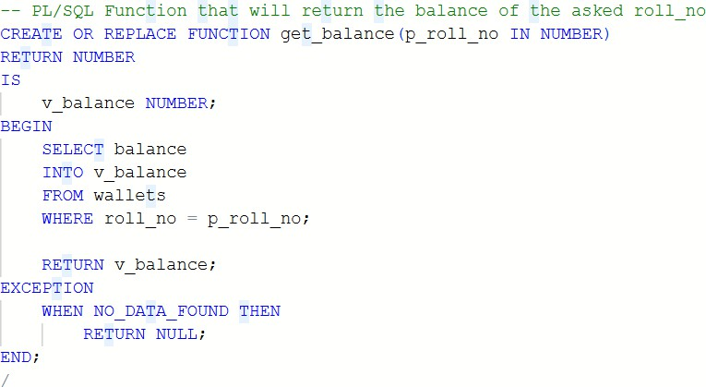
get_balance() function:

Testing the function:

Output:
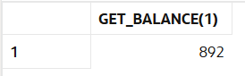

update_wallet_active_status procedure:
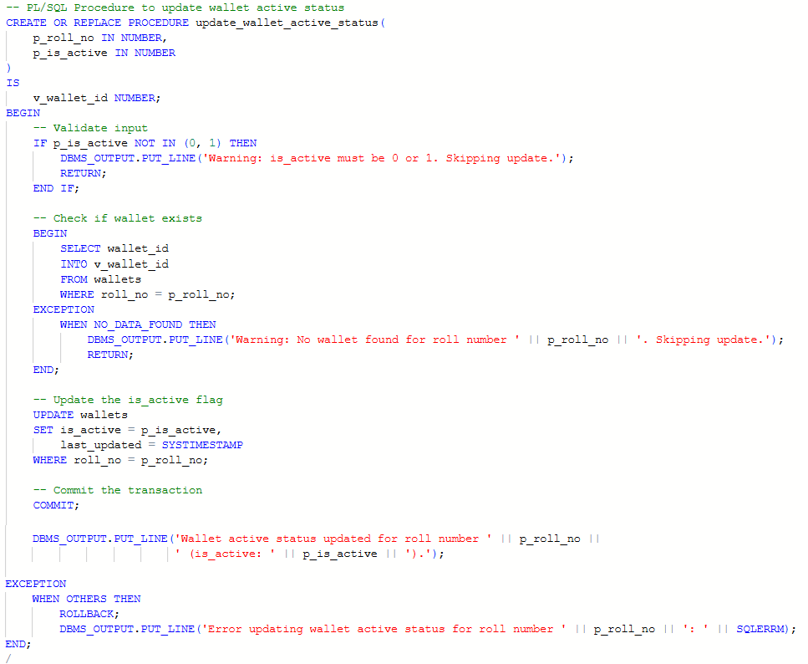

Testing the procedure:
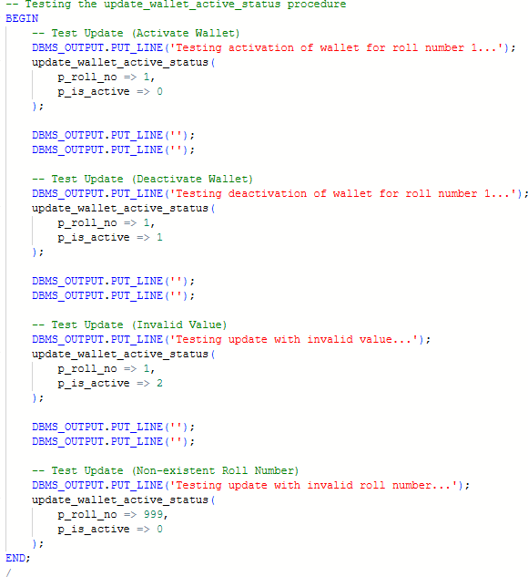

Output:
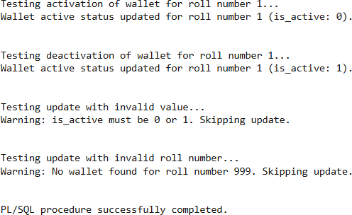

process_topup procedure:
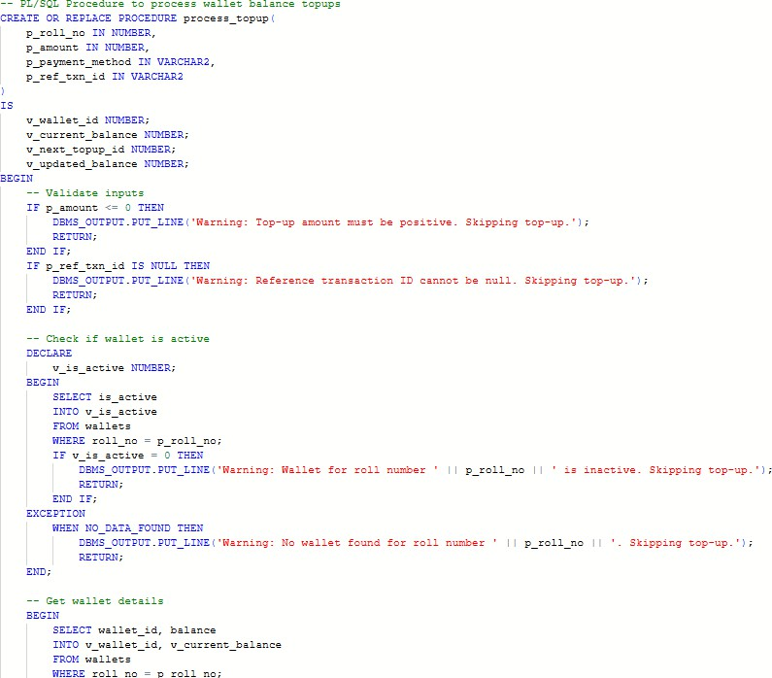
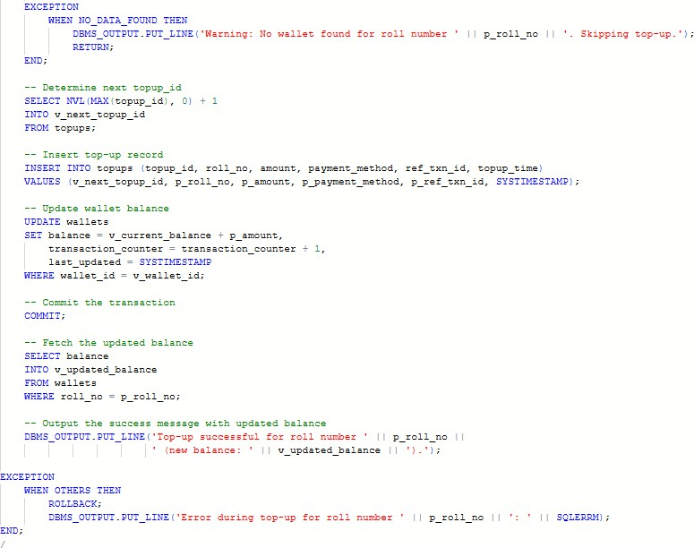

Testing the procedure:
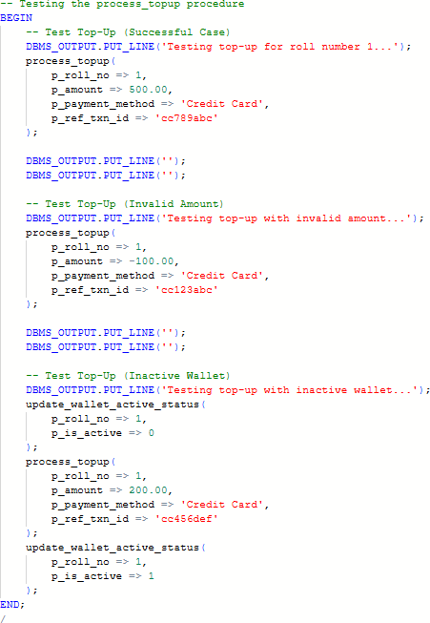
Output:
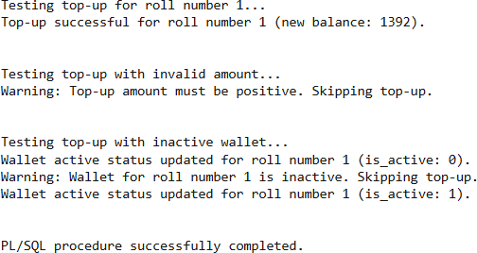

process_transaction procedure:
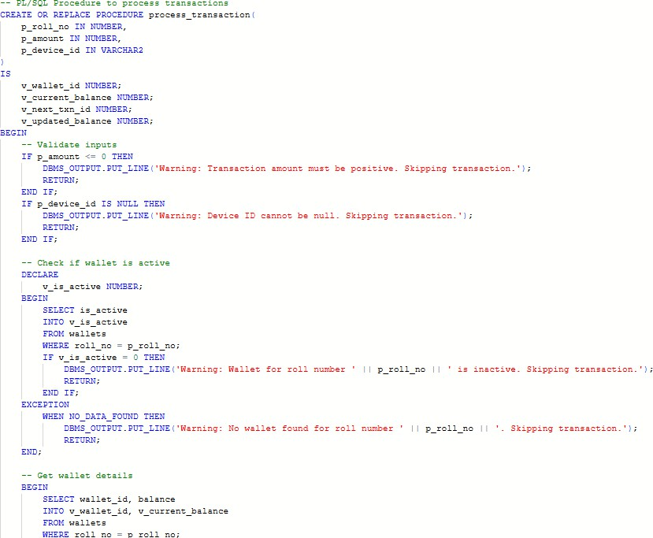
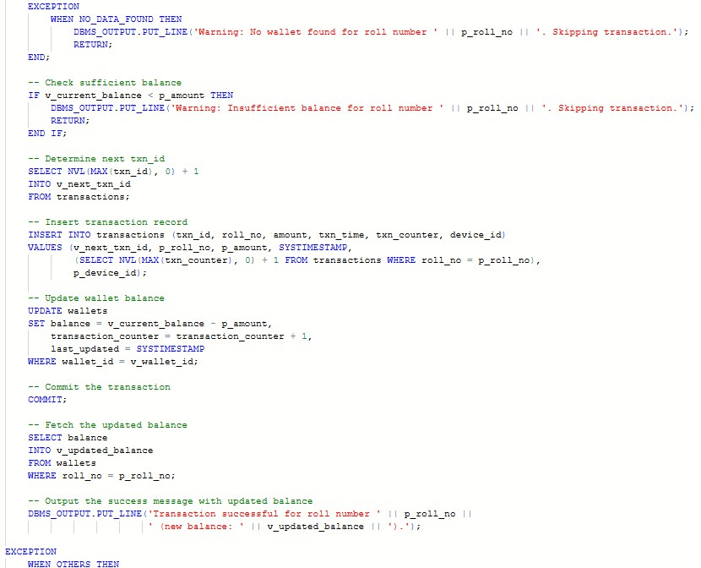

Testing the procedure:
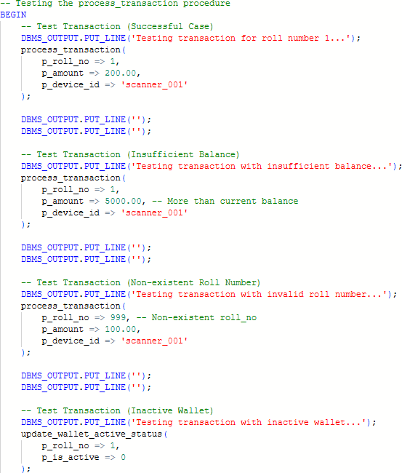
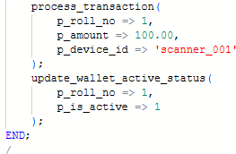

Output:
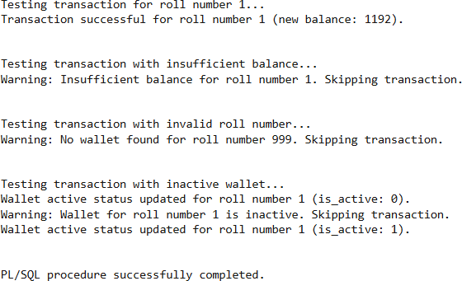

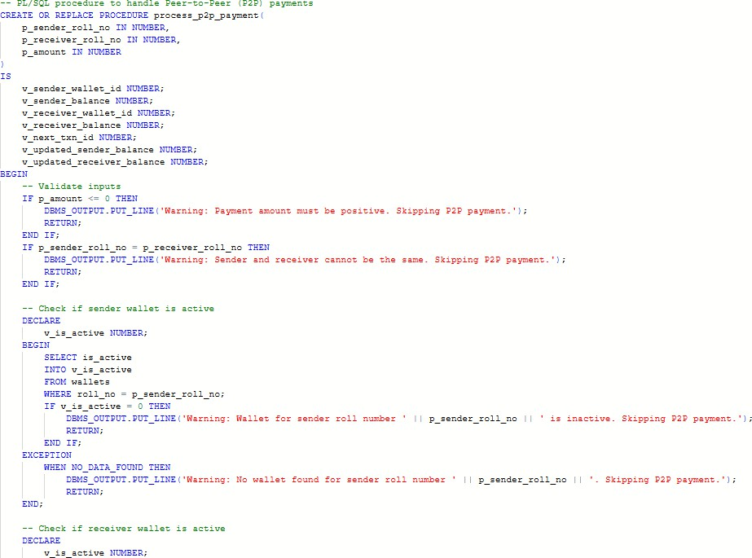
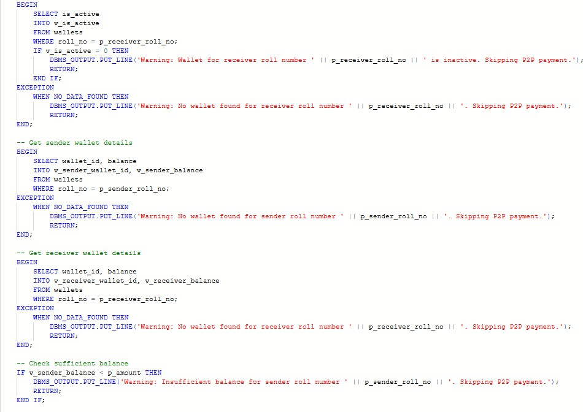
process_p2p_payment procedure:

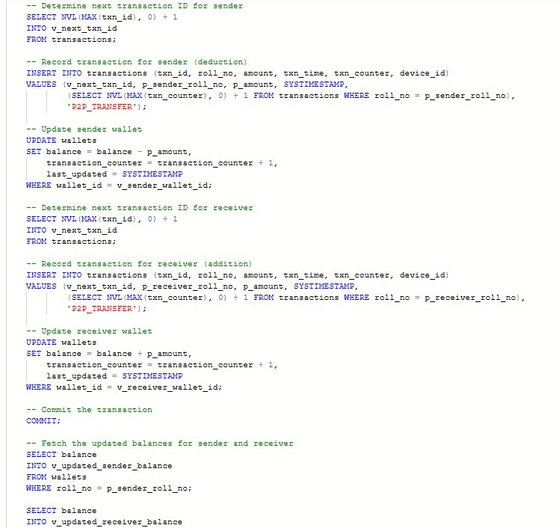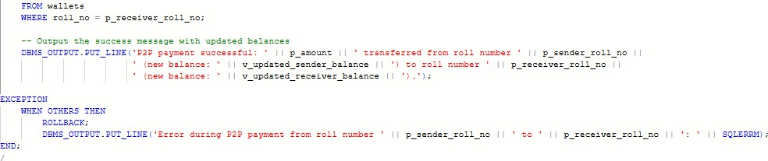

Testing the procedure:
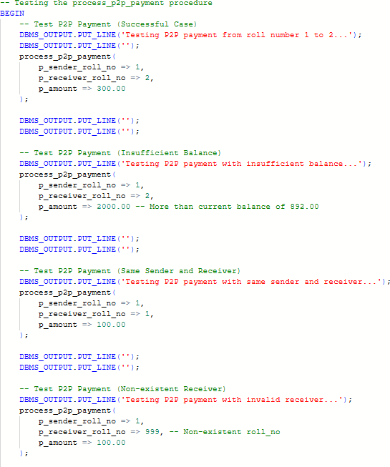
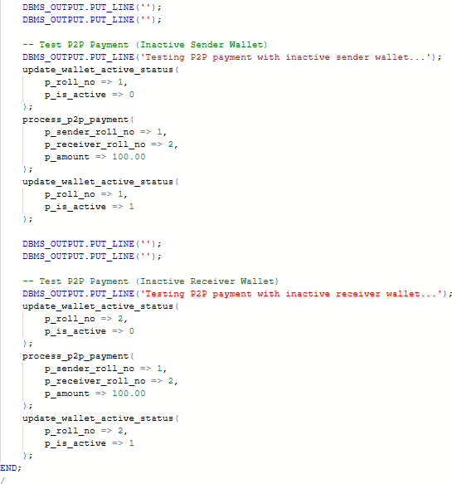

Output:
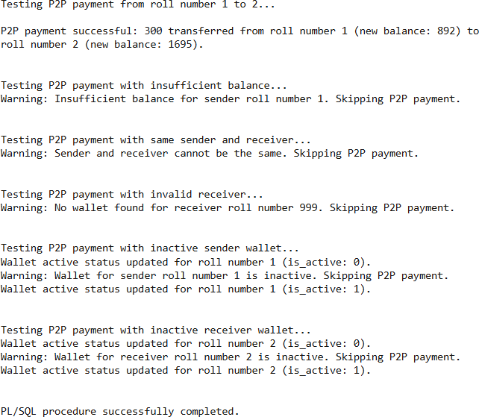

Conclusion
The "CampusPay" RFID-based unified Tap-and-Pay system effectively addresses the challenges of a fragmented payment ecosystem at Thapar Institute of Engineering and Technology by introducing a solution that utilizes existing ID cards and a centralized SQL database. This RFID-based unified Tap-and-Pay system enables students and staff to conduct seamless transactions across campus with a single platform, eliminating the need for multiple apps and reducing reliance on internet connectivity. Vendors benefit from simplified reconciliation and settlement processes, supported by accurate and timely financial reporting, while the system’s security features—such as the “is_active” flag for wallet deactivation and centralized transaction logging—minimize fraud risks and ensure data integrity.
CampusPay’s scalable and sustainable design positions it as a cost-effective model for future expansion, with potential integrations like advanced spending analytics and campus resource management tools. By leveraging existing RFID infrastructure and low-cost scanners, the RFID-based unified Tap-and-Pay system offers a practical solution that can serve as a blueprint for other educational institutions. This project not only enhances the daily experience of TIET’s community but also underscores the institute’s commitment to innovation, establishing a cashless, efficient, and secure payment environment that aligns with its forward-thinking ethos.

References
- Class notes and lab assignment
- https://dev.mysql.com/doc/
- https://www.w3schools.com/sql/
- https://learn.sparkfun.com/tutorials/rfid-basics/all
- https://www.nxp.com/docs/en/data-sheet/MF1S50YYX_V1.pdf

